12. Remarks for users of previous autoISF versions V 3.0

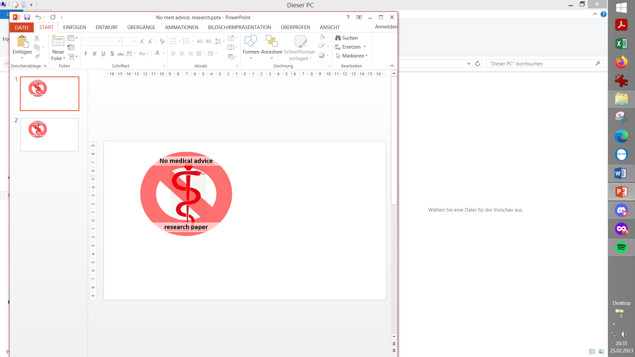
Please note that with autoISF you are in an early-dev. environment, where the user interface is not optimized for safety of users who stray away from intended ways to use. Good safety features exist, but these are only as good as the development-oriented user understands and implements them. This is not a medical product, refer to disclaimer in section 0

12.1 Main innovations in autoISF 3.1.0

Except for things relating to 1-minute Libre readings, the main point of migrating from the previous AAPS 3.2.0.4+autoISF 3.0.1 to the current newest AAPS 3.3 3.a+autoISF3.1.0 was really to update autoISF to the changes done in AAPS Master.
For instance, there is an extra AUTO ISF tab now, instead having different SMB tab designs depending on selected modes.
The FCL e-Book needed only very minor adaptations. Changes in autoISF are sketched below, more see in autoISF Quick Guide @ Github/ga-zelle/autoISF.
From there:
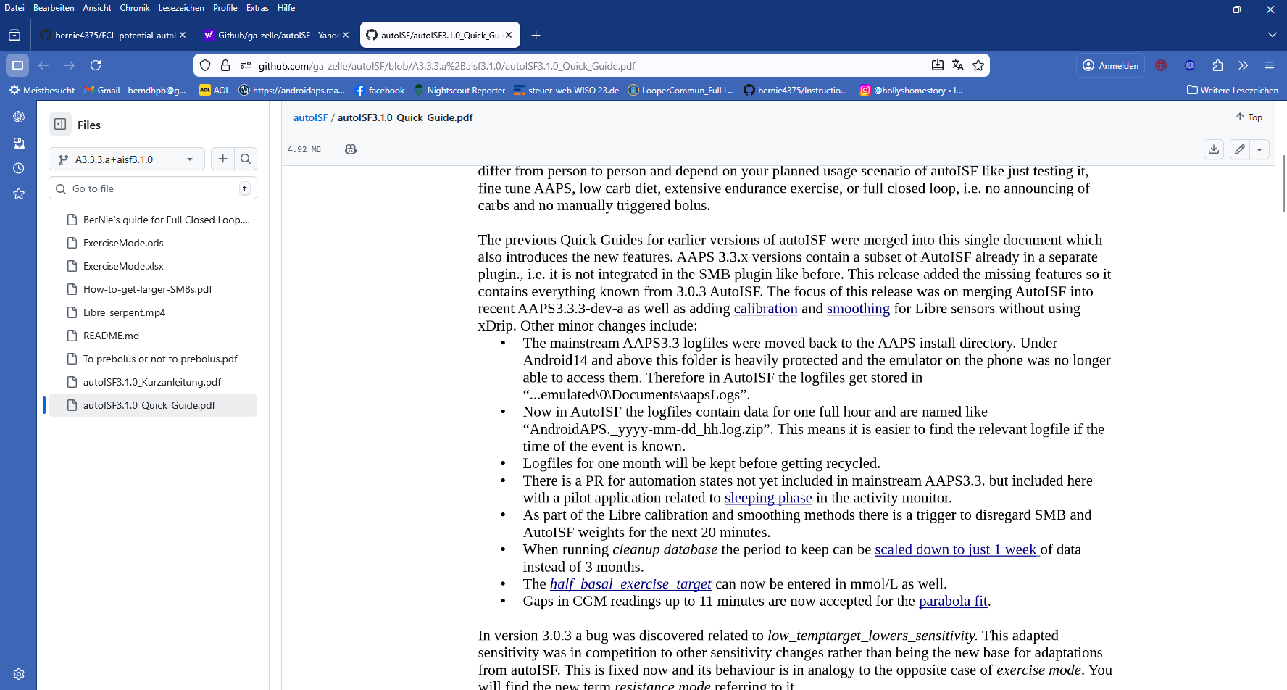

12.2 Main innovations in (previous) autoISF 3.0.1

- Integration of Libre3 in 1-minute mode
- Cancellation of some parameters and options (none of which were recommended to use in past FCL guidance documents):
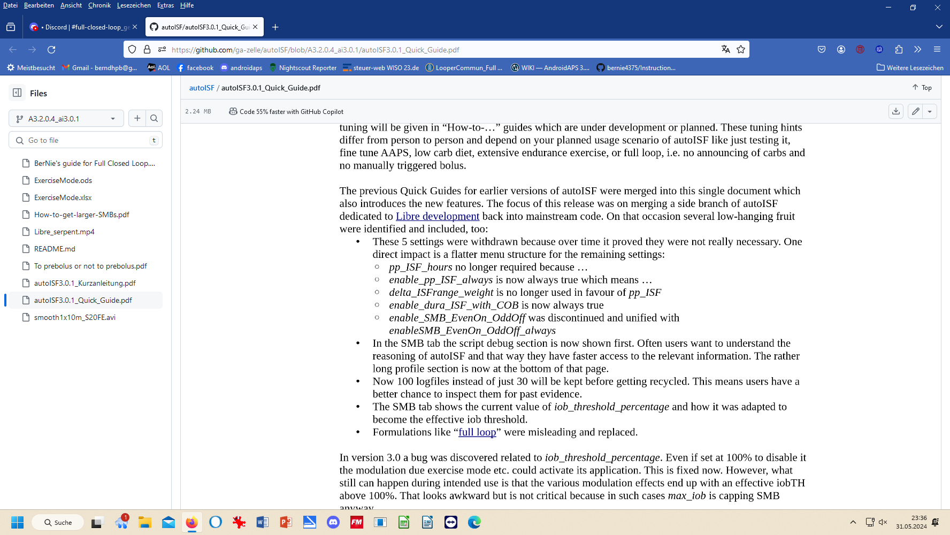
- About 3 times as many logfiles can be stored in the phone, making copying zip files into your PC less often necessary
- Clearer structure of the SMB tab
  - now with all autoISF effects detailed on top page
  - iobTH declared
  - language clearer:
- 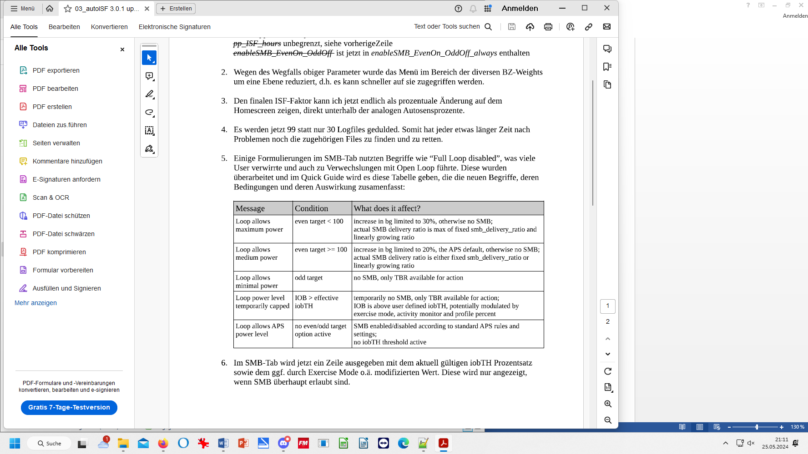
- AAPS home screen on smartphone now shows autoISF result (sens/profile.sens = amplication factor on the profile_ISF) underneath the Autosens %
See also preface in the Quick Guide: https://github.com/ga-zelle/autoISF/blob/A3.2.0.4_ai3.0.1/autoISF3.0.1_Quick_Guide.pdf

Also an error in the previous 3.0 version was rectified:
In 3.0 there was a bug related to the iob_threshold_percentage being inactive when setting it to 100%. Once modulated by exercise or similar it became active unintentionally

12.2 Implications regarding your previous FCL settings

The changes in autoISF were minor.
Please refer to AAPS readthedocs regarding the important changes in the migration to the newest AAPS version.

The following related to the previous autoISF update
Odd target => SMB-off
As the even/odd logic now uniformly applies to profile targets and tio TT, users who had previously only used the od TT/SMB shut off MUST now extend this setting to profile targets.
This means, you need to look through your bg targets in your profile and may have to adjust the bg target for some hours by 1 unit (or decimal point in mmol).
Cancellation of delta_ISF
If you had followed the suggestions – also in previous versions of this e-book - you would not have made use of any of the cancelled feature.
Else you may have to switch to pp_ISF now for management of the near-linear bg rise phase in some meals. See section 4.4
Storing more logfiles in the internal phone memory
You can wait about 3 times longer than you were used to, for securing your logfiles in your PC.
Lower hurdles for “looking under the hood” of your autoISF
Looking the current aggressiveness your loop works under (ISF and iobTH actually in use) is made much easier in the reorganized SMB tab.
The updated FCL e-book now comes with detailed guidance how to use the emulator, both on PC and on (Android) phone (sections 10 and 11.)

